Lampiran 1
Hasil Kultur, sub Tipe dan Uji Kepekaan M.tuberculosis
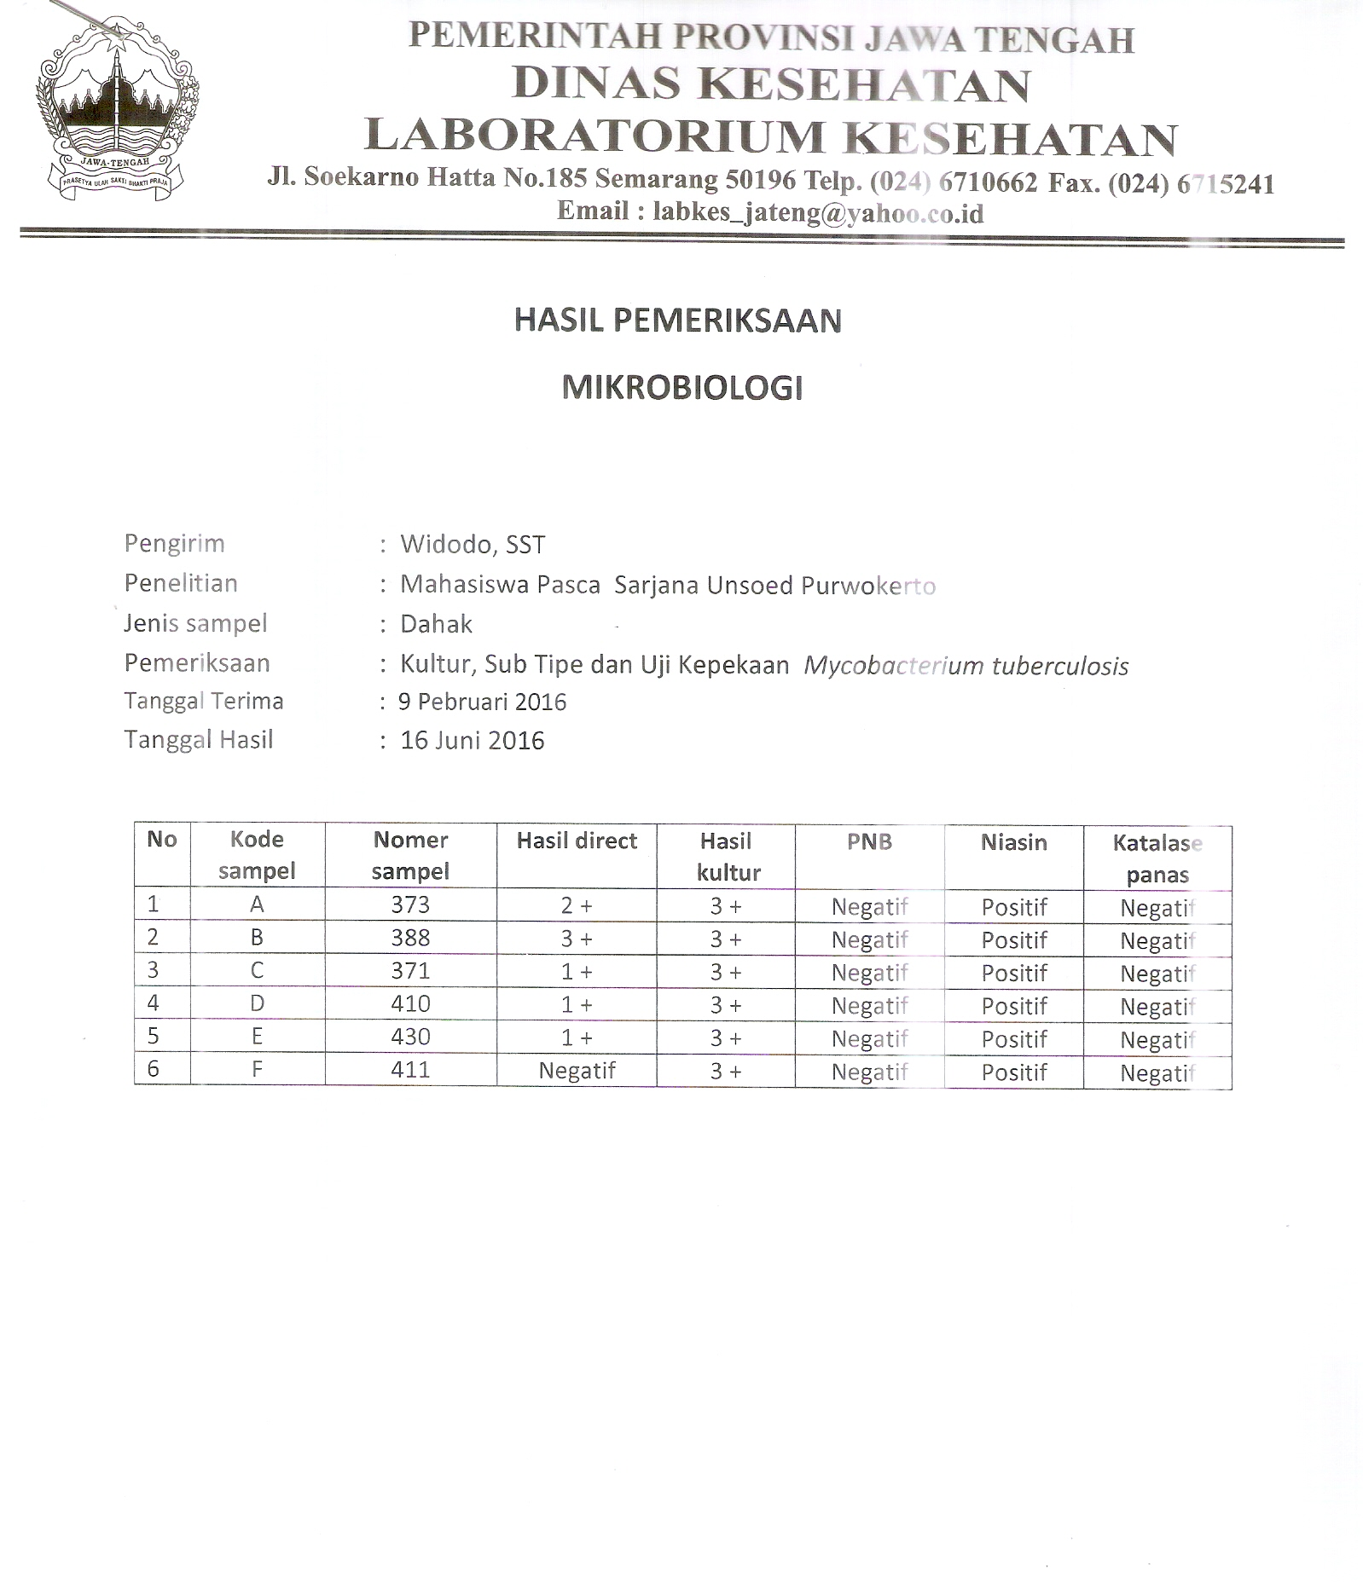
Lampiran 2
Hasil pengukuran panjang dan lebar sel Mycobacterium tuberculosis

Lampiran 3
Hasil Pengamatan Morfologi sel Mycobacterium tuberculosis
Lampiran 4
Pertumbuhan pada media LJ setelah pemaparan INH 0,5 µg/ml
Tanggal perlakuan = 15 s/d 18 Maret 2016
 |  | Pengamatan perlakuan
No | No LAP | Minggu I | Minggu II | Minggu III | Minggu IV | Minggu V
1 | A.1.1 | Kon | Kon | Kon | Kon | Kon
2 | A.1.2 | 0 | 0 | 0 | 5 | 27
3 | A.1.3 | 0 | 0 | 0 | 11 | 200
4 | A.1.4 | 0 | 0 | 0 | 70 | 100
5 | A.1.5 | 0 | 0 | 0 | 50 | 200
6 | A.1.6 | 0 | 0 | 0 | 6 | 40
7 | B.2.1 | Kon | Kon | Kon | Kon | Kon
8 | B.2.2 | 0 | 0 | 0 | 5 | 50
9 | B.2.3 | 0 | 0 | 0 | 3 | 75
10 | B.2.4 | 0 | 0 | 0 | 25 | 20
11 | B.2.5 | 0 | 0 | 0 | 7 | 41
12 | B.2.6 | 0 | 0 | 0 | 18 | 29
13 | C.3.1 | 0 | 0 | 0 | 2 | 98
14 | C.3.2 | 0 | 0 | 0 | 1 | 15
15 | C.3.3 | 0 | 0 | 0 | 0 | 25
16 | C.3.4 | 0 | 0 | 0 | 6 | 35
17 | C.3.5 | 0 | 0 | 0 | 5 | 21
18 | C.3.6 | 0 | 0 | 0 | 5 | 31
19 | D.4.1 | 0 | 0 | 0 | 0 | 3
20 | D.4.2 | 0 | 0 | 0 | 0 | 10
21 | D.4.3 | 0 | 0 | 0 | 0 | 12
22 | D.4.4 | 0 | 0 | 0 | 0 | 0
23 | D.4.5 | 0 | 0 | 0 | 0 | 0
24 | D.4.6 | 0 | 0 | 0 | 0 | 0
25 | H37RV | 0 | 20 | 50 | 200 | 500
26 | HE | 0 | 5 | 20 | 100 | 200
27 | TO | 0 | 25 | 70 | 300 | 500

 |  | Pengamatan perlakuan
No | No. Lap | Minggu I | Minggu II | Minggu III | Minggu IV | Minggu V
1 | E.1.1 | 0 | 0 | 0 | 0 | 50
2 | E.1.2 | 0 | 0 | 0 | 0 | 0
3 | E.1.3 | 0 | 0 | 0 | 0 | 0
4 | E.1.4 | 0 | 0 | 0 | 30 | 100
5 | E.1.5 | 0 | 0 | 0 | 0 | 45
6 | E.1.6 | 0 | 0 | 0 | 50 | 100
7 | F.2.1 | Kon | Kon | Kon | Kon | Kon
8 | F.2.2 | 0 | 0 | 0 | 0 | 5
9 | F.2.3 | 0 | 0 | 0 | 50 | 60
10 | F.2.4 | 0 | 0 | 0 | 3 | 30
11 | F.2.5 | 0 | 0 | 0 | 25 | 50
12 | F.2.6 | 0 | 0 | 0 | 0 | 0
13 | G.3.1 | 0 | 0 | 0 | 5 | 40
14 | G.3.2 | 0 | 0 | 0 | 75 | 120
15 | G.3.3 | 0 | 0 | 0 | 0 | 0
16 | G.3.4 | 0 | 0 | 0 | 6 | 25
17 | G.3.5 | 0 | 0 | 0 | 7 | 30
18 | G.3.6 | 0 | 0 | 0 | 0 | 0
19 | H.4.1 | 0 | 0 | 0 | 0 | 0
20 | H.4.2 | 0 | 0 | 0 | 1 | 13
21 | H.4.3 | 0 | 0 | 0 | 0 | 0
22 | H.4.4 | 0 | 0 | 0 | 5 | 20
23 | H.4.5 | 0 | 0 | 0 | 20 | 27
24 | H.4.6 | 0 | 0 | 0 | 0 | 0

Satuan jumlah koloni

Lampiran 7
UJI STATISTIK
Tests of Normality^{b,c,d,e}
 |  | lama waktu pemaparan terhadap Isoniasid 5 ug/ml |  | Kolmogorov-Smirnovª |  |  |  | Shapiro-Wilk
 |  |  |  | Statistic | df |  | Sig. | Statistic |  | df | Sig.
Pertumbuhan koloni pada LJ |  | 24 jam |  | .232 | 6 |  | .200* | .859 |  | 6 | .186
 |  | 48 jam |  | .125 | 6 |  | .200* | .996 |  | 6 | .999
 |  | 72 jam |  | .366 | 6 |  | .012 | .720 |  | 6 | .010
 |  | 96 jam |  | .277 | 6 |  | .165 | .782 |  | 6 | .040
Uji Ketahanan Garam 5 % |  | 24 jam |  | .492 | 6 |  | .000 | .496 |  | 6 | .000
 |  | 48 jam |  | .398 | 6 |  | .003 | .705 |  | 6 | .007
 |  | 96 jam |  | .392 | 6 |  | .004 | .701 |  | 6 | .006
Uji Katalase Semikuantitatif |  | 24 jam |  | .294 | 6 |  | .114 | .783 |  | 6 | .041
 |  | 48 jam |  | .236 | 6 |  | .200* | .865 |  | 6 | .208
 |  | 72 jam |  | .271 | 6 |  | .191 | .792 |  | 6 | .050
 |  | 96 jam |  | .280 | 6 |  | .154 | .802 |  | 6 | .061
Test Statistics^{a,b}
 | Pertumbuhan koloni pada LJ |  | Uji Ketahanan Garam 5 % |  |  | Uji Katalase Semikuantitatif
Chi-Square | 7.013 |  | 8.000 |  |  | 7.152
df | 1 |  | 1 |  |  | 1
Asymp. Sig. | .008 |  | .005 |  |  | .007
a. Kruskal Wallis Test
b. Grouping Variable: lama waktu pemaparan terhadap Isoniasid 5 ug/ml

