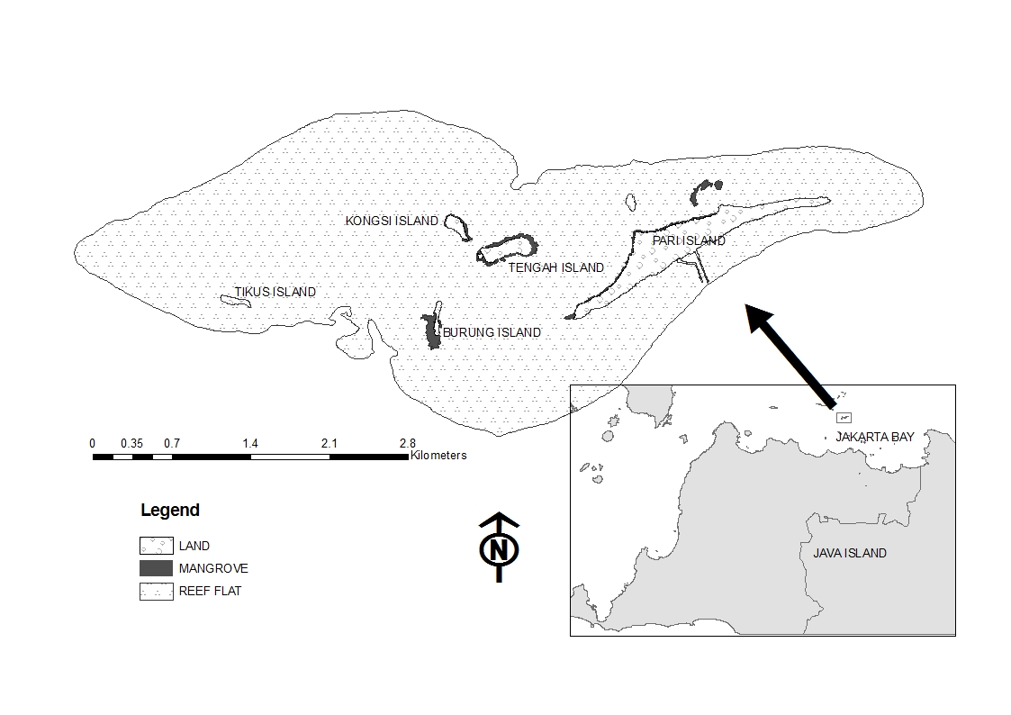
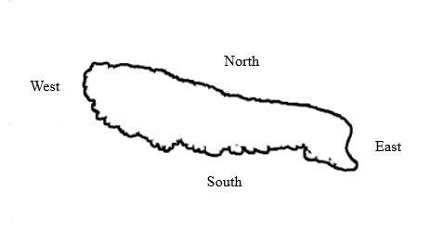
Pulau Tikus Island

Gambar 1. Peta lokasi penelitian Pulau Tikus Gugusan Pulau Pari.

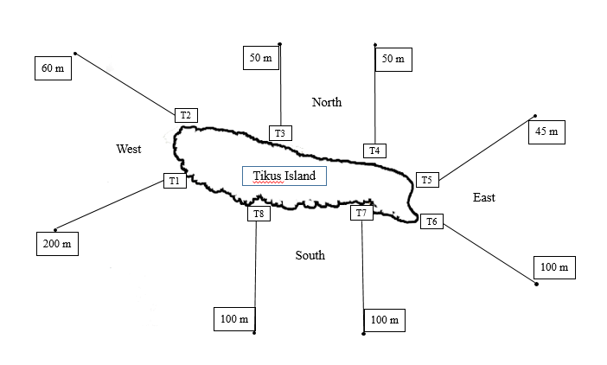
Gambar 2. Metode transek kuadrat di Pulau Tikus.

Tabel 1. Komposisi famili dan spesies kepiting Brachyura.

Family | Spesies | TOTAL SPESIES
 |  | Barat | Utara | Timur | Selatan
Portunidae | Thalamita crenata | 14 | 5 | 6 | 6
 | Thalamita integra | 9 | 3 | 5 | 1
 | Thalamita admete | 5 | 0 | 4 | 4
 | Thalamita cooperi | 0 | 0 | 1 | 2
 | Portunus granulatus | 2 | 1 | 0 | 0
 | Portunus sp. | 0 | 3 | 0 | 0
Majidae | Tiarinia angusta | 0 | 0 | 1 | 0
 | Menaethius monoceros | 4 | 3 | 3 | 1
 | Micippa sp. | 3 | 1 | 1 | 0
Galenidae | Halimede fragifer | 0 | 1 | 0 | 0
Dromiidae | Dromidia sp. | 0 | 0 | 1 | 0
Calappidae | Calappa bicornis | 0 | 0 | 0 | 1
Ocypodidae | Ocypode stimpsoni | 0 | 1 | 0 | 5
Grapsidae | Pachygrapsus plicatus | 1 | 0 | 0 | 0
Porcellanidae | Petrolisthes asiaticus | 0 | 0 | 1 | 0
 | Psidia serratifrons | 1 | 1 | 9 | 1
Macrophthalmidae | Macrophthalmus boscii | 0 | 1 | 0 | 1
Xanthidae | Xanthias sp. | 1 | 0 | 0 | 0
 | Euxanthus exsculptus | 0 | 1 | 0 | 0
 | Xanthias lamarcki | 1 | 0 | 0 | 0
 | Pilodius areolatus | 4 | 4 | 7 | 1
 | Chlorodiella nigra | 2 | 1 | 1 | 1
 | Etisus sp. | 2 | 0 | 1 | 0
 | Chlorodiella sp. | 2 | 0 | 2 | 0
 | Platypodia granulosa | 0 | 0 | 1 | 0
 | Leptodius exaratus | 0 | 0 | 0 | 1
 | Actaeodes tomentosus | 0 | 0 | 3 | 0
 | Atergatis floridus | 0 | 1 | 1 | 0
 | Banareia sp. | 4 | 0 | 0 | 0
Pilumnidae | Pilumnus vespertilio | 10 | 4 | 0 | 0
 | Pilodius granulatus | 2 | 0 | 5 | 1
 | Heteropilumnus ciliatus | 0 | 0 | 4 | 1
 | Actumnus squamosus | 2 | 1 | 0 | 0
 | Actumnus sp. | 0 | 0 | 0 | 1
Total of individuals crab |  | 69 | 32 | 57 | 28
Total species |  | 18 | 16 | 19 | 15

Gambar 3. Nilai indeks keanekaragaman (H’) dan dominansi (D).

Gambar 4. Nilai indeks kemerataan Pielou (J).

Gambar 5. Nilai keseluruhan indeks keanekaragaman (H’), dominansi (D) dan kemerataan Pielou (J).

