Lampiran 1a. Hasil isolasi jamur rizosfer mangrove pada labu Erlenmeyer

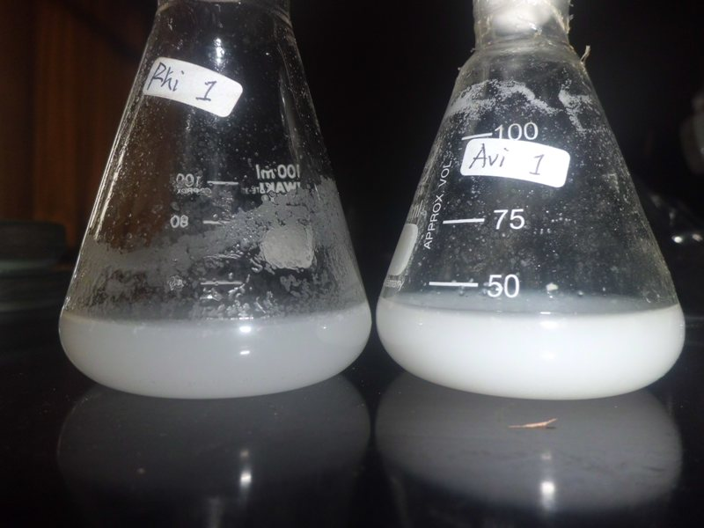

Lampiran 1b. Sel khamir isolat Rhi2H1 iso3 dengan pembesaran 100x10

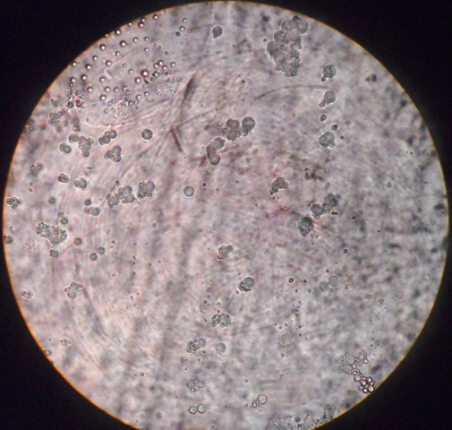.

Sel khamir

Lampiran 2a. *Pseudomiselium* khamir isolat Avi2H5 iso2 pembesaran 100x10

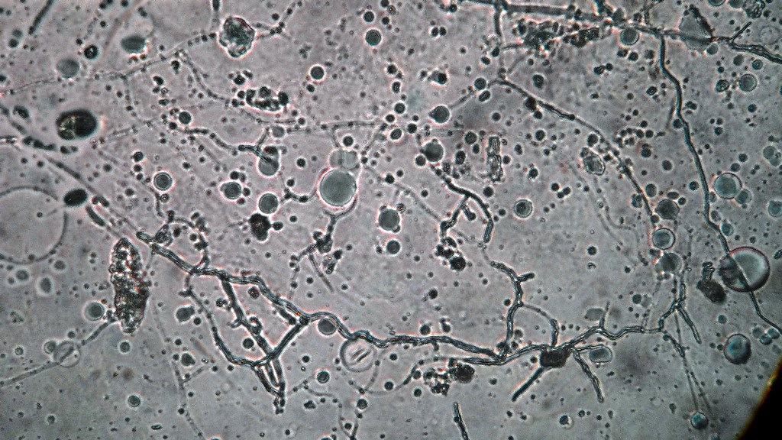

Lampiran 2b. Biomassa jamur dari uji kualitatif.

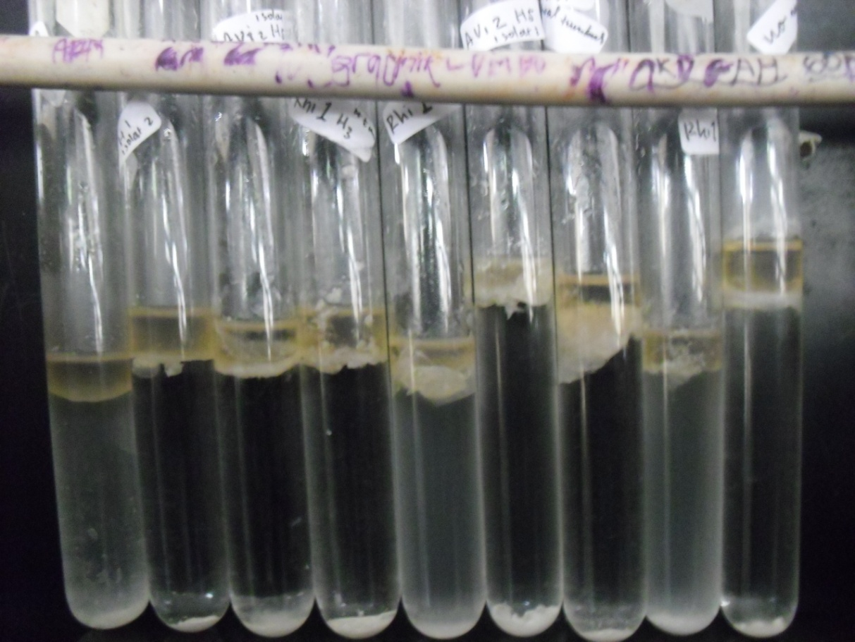

Lampiran 3a. Hasil identifikasi API 20 C AUX isolat Avi2H5 iso2.

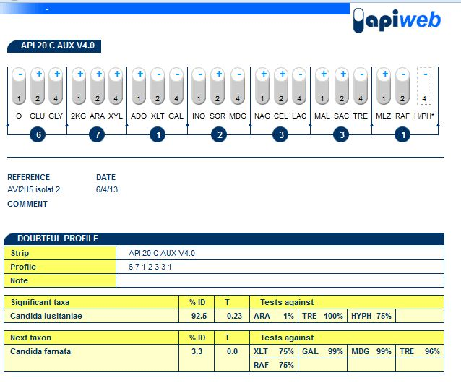

Lampiran 3b. Hasil identifikasi API 20 C AUX isolat Rhi2H1 iso3.



|  |  |  |  |  |  |
| --- | --- | --- | --- | --- | --- |
| No | Nama Isolat | Ulangan | | | |
| a | b | C | Rata2 |
| **Hari ke-7** | | | | | |
| 1 | K1U0 | 7,15 | 6,88 | 6,89 | 6,97 |
| 2 | K1U1 | 7,89 | 7,96 | 7,74 | 7,86 |
| 3 | K1U2 | 8,37 | 8,08 | 8,08 | 8,18 |
| 4 | K1U3 | 7,53 | 7,60 | 8,69 | 7,94 |
| 5 | K2U0 | 7,01 | 6,88 | 6,95 | 6,95 |
| 6 | K2U1 | 6,94 | 7,95 | 7,31 | 7,4 |
| 7 | K2U2 | 7,24 | 8,59 | 8,02 | 7,95 |
| 8 | K2U3 | 7,61 | 7,94 | 7,65 | 7,73 |
| 9 | K3U0 | 7,28 | 7,18 | 7,13 | 7,20 |
| 10 | K3U1 | 7,56 | 7,47 | 7,51 | 7,51 |
| 11 | K3U2 | 7,64 | 7,58 | 7,44 | 7,55 |
| 12 | K3U3 | 7,28 | 7,35 | 7,44 | 7,36 |
| **Hari ke-14** | | | | | |
| 1 | K1U0 | 7,83 | 7,30 | 6,42 | 7,18 |
| 2 | K1U1 | 7,75 | 8,46 | 8,54 | 8,25 |
| 3 | K1U2 | 8,49 | 8,73 | 8,80 | 8,67 |
| 4 | K1U3 | 8,63 | 8,98 | 8,99 | 8,87 |
| 5 | K2U0 | 6,94 | 6,88 | 6,80 | 6,87 |
| 6 | K2U1 | 8,38 | 7,82 | 8,63 | 8,28 |
| 7 | K2U2 | 8,03 | 8,67 | 8,71 | 8,47 |
| 8 | K2U3 | 8,85 | 8,75 | 8,84 | 8,81 |
| 9 | K3U0 | 7,71 | 7,31 | 7,03 | 7,35 |
| 10 | K3U1 | 7,50 | 7,74 | 8,37 | 7,87 |
| 11 | K3U2 | 7,86 | 7,93 | 7,92 | 7,90 |
| 12 | K3U3 | 8,03 | 8,15 | 7,83 | 8,00 |
| **Hari ke-21** | | | | | |
| 1 | K1U0 | 6,69 | 6,66 | 6,38 | 6,57 |
| 2 | K1U1 | 8,25 | 8,04 | 7,79 | 8,03 |
| 3 | K1U2 | 8,78 | 8,82 | 8,81 | 8,80 |
| 4 | K1U3 | 8,77 | 8,93 | 8,96 | 8,89 |
| 5 | K2U0 | 7,10 | 6,93 | 6,95 | 6,99 |
| 6 | K2U1 | 7,32 | 8,80 | 8,79 | 8,30 |
| 7 | K2U2 | 8,76 | 8,90 | 8,94 | 8,87 |
| 8 | K2U3 | 8,88 | 9,08 | 9,09 | 9,02 |
| 9 | K3U0 | 7,05 | 7,06 | 7,14 | 7,08 |
| 10 | K3U1 | 8,56 | 8,64 | 8,43 | 8,54 |
| 11 | K3U2 | 8,77 | 8,78 | 8,81 | 8,79 |
| 12 | K3U3 | 8,92 | 9,02 | 9,08 | 9,01 |

Lampiran 4. Data nilai pH pada masa inkubasi.

Lampiran 5. Hasil analisis SPSS pertumbuhan isolat.

| **Levene's Test of Equality of Error Variancesa** | | | |
| --- | --- | --- | --- |
| Dependent Variable:total plate count | | | |
| F | df1 | df2 | Sig. |
| 3.279 | 11 | 36 | .003 |
| Tests the null hypothesis that the error variance of the dependent variable is equal across groups. | | | |
| a. Design: Intercept + KU + IS + KU * IS | | | |

| **Tests of Between-Subjects Effects** | | | | | |
| --- | --- | --- | --- | --- | --- |
| Dependent Variable:total plate count | | | | | |
| Source | Type III Sum of Squares | df | Mean Square | F | Sig. |
| Corrected Model | 380138.729a | 11 | 34558.066 | .658 | .768 |
| Intercept | 927130.021 | 1 | 927130.021 | 17.640 | .000 |
| KU | 53685.229 | 3 | 17895.076 | .340 | .796 |
| IS | 46673.167 | 2 | 23336.583 | .444 | .645 |
| KU * IS | 279780.333 | 6 | 46630.056 | .887 | .514 |
| Error | 1892112.250 | 36 | 52558.674 |  |  |
| Total | 3199381.000 | 48 |  |  |  |
| Corrected Total | 2272250.979 | 47 |  |  |  |
| a. R Squared = ,167 (Adjusted R Squared = -,087) | | | | | |